SELECTKBEST ALGORITHM REPORT

K=1

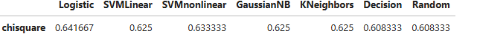K=2

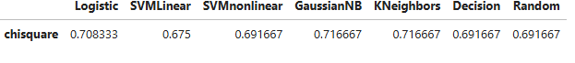K=3

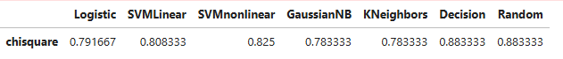

K=4

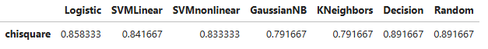K=5

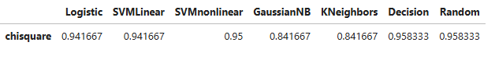

**Result:**

The algorithms works when the input or variables are 5 that is k=5.